

## **Are there any more features and versions planned?** We will be updating the asset from time to time, check the asset store for updates and to see version notes by clicking on the version notes (ex: v1.2 etc).

# IMPORTANT REMINDER: You can place how many shapes you like into the scene, and it will automatically collects how many you have to win the game. Be sure to put the ‘win zone’ shape into the ‘drag zone’ shape’s ‘win zone field’ in the inspector. see page 5 onwards for more information.

**INTRODUCTION**

**Thank you for buying this KIT, we really appreciate your support.**

**Welcome to 2D Simple Educational Puzzle Match - Drag & Drop Mobile Game KIT documentation. This will tell you everything you need to know about the KIT and how to start building your own game easy in 1-2-3.**

This pack features a fully functional level-selection menu and level-unlock system where you can unlock levels by completing them for next time. It also save your last progress and you can create the game with easy - all you need to do is place the essential prefabs, add the shapes, drag them to the win zone where you want and you are good to go!

This documentation will guide you on how to start creating your own game, how to add level-selection menu and much more which also hopefully covers any questions you may have. If not then it’s not a problem, just contact us at our website on [**www.steelkrill.com**](http://www.steelkrill.com) **and we get back to you!**

**Create a new empty project**

Create a new empty project, set defaults for 2D and Import this package into the NEW EMPTY PROJECT.

**Please note:** Importing into an OLD Project may result in damaging your old project.

**Import Package to unity**

Import the package inside Unity using the import button, be sure that you select 2D and ALL are selected.

While the importing is in progress, wait for it and have some tea or coffee so we can begin creating our nice looking game. Firstly though, be sure to take a look at all the files and read this documentation, otherwise you will not really understand the use of this package.

**OVERVIEW of THE files**

Remember, the most important prefabs are in the Prefabs folder and the settings located in the prefabs folder.

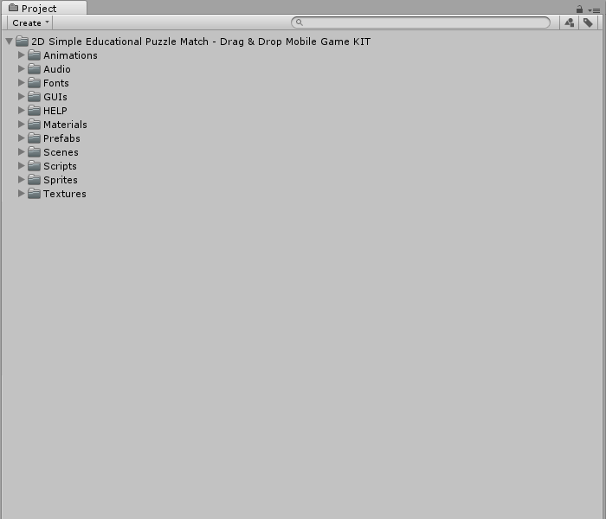

These are what you should typically have (folders may change during version updates) once you imported the package. Below we will explain some of the folders.

**Explanation of IMPORTANT fOLDERS**

**Animations folder**  
Animations for your game, I suggest you do not touch these unless you want to change the animations.

**Audio folder**Audio folder contains all the KIT sounds and music including audio and sounds FX.

**Fonts folder**Fonts which you can use for your game.

**GUIs folder**This folder contains the GUIs prefabs to use in game such as the GUIs, HUDs and such.

**HELP folder**Text of hints, text tutorials and documentation for creating your game.

**Materials folder**The materials of the game.

**Prefabs folder**Prefabs folder which contains all your general prefabs such as the shapes, ready-to-use backgrounds and settings such as background music, game manger, game ending sound and much more.

**Prefabs > Ready-To-Use Backgrounds folder**The image backgrounds you can use for your game which are ready-to-use as prefabs.

**Prefabs > Animal Shapes (Drag Prefabs)\**These are the drag prefabs shapes that you can be dragging in the scene.

**Prefabs > Animal Shapes (Win Prefabs)**These are the win zone prefabs shapes that you need to drag the other ones into.

**Prefabs > Settings**All these prefabs are needed in order to run the game correctly – such as game manager, game ending sound, main camera and such.

**Sprites folder**This folder contains all your sprites for the prefabs. Such as the coins sprites, player sprites, spike sprites and etc.

**Scenes folder**Folder that will contain the example scene and the main menu which you are free to modify.

**Scripts folder**Important folder which contains IMPORTANT scripts for your game..

**Textures folder**Remaining textures used for your models, prefabs and such.

MAKING THE RIGHT SCREEN SIZE

This packages is both for mobile and desktop. For the best experience, we suggest you change the camera display so it will be the same screen you will be using for mobile (mostly) you can just change it from the Free Aspect to something else to you needs – or create a new display.

When you get the package, you will see that you are In Free Aspect

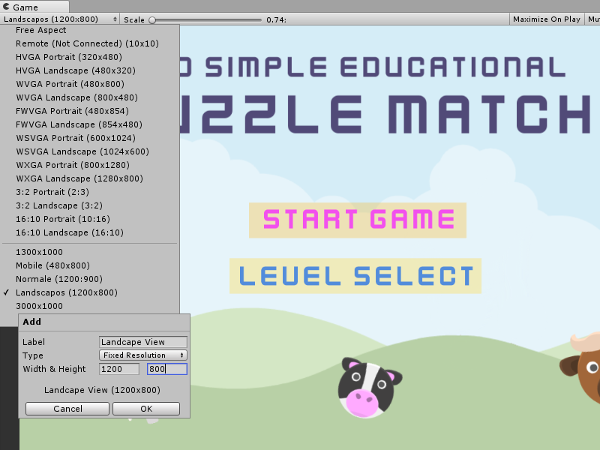

Click on the little + sign at the bottom and this window will pop up.

**Right anything you want in the Label and in the Width and Height do the following:**

Width: 1200

Height: 800

Also, leave the type to Fixed Resolution.

Once you are done just press ok and you are good to go. The screen size now is better for testing out the scene of the mobile demos. This is totally optional and you can still test out the demos, however some developers will prefer to see the same screen size for mobile they will be using for creating the games on mobile.

**first time when importing the package**

When you import the package for the very first time, to make it work fully and see all the features in action I suggest you put the demo scenes into your BUILD SETTINGS in order for it to work. Unity will remove the scenes build when you import a package in a new project so you need to do this manually.

The first time you import the package, all the levels, menu and level selection menu are NOT in the build settings. If you first try out the scenes and it gives you the error '1 or any other number couldn't be loaded because it has not been added to the build settings' then you have to go to the FILE > BUILD SETTINGS and click open up the GameMenu scene.

the build settings' then you have to go to the FILE > BUILD SETTINGS and click open up the GameMenu scene.

Go to your FILE > BUILD SETTINGS and you should see something like this. Go to your SCENES FOLDER and click on the GameMenu scene. This should always be your first scene followed by the LevelSelectionMenu. Go to FILE > BUILD SETTINGS when you have the open scene GameMenu and click on ADD OPEN SCENE and this will add your scene to the build settings. Click on the other scene called LevelSelectionMenu in the SCENES FOLDER and do the same with that one. Then go to your Levels folder and add each scene from level 1 to level 5. You can now test out the package fully and as you can see everything should be working in order.

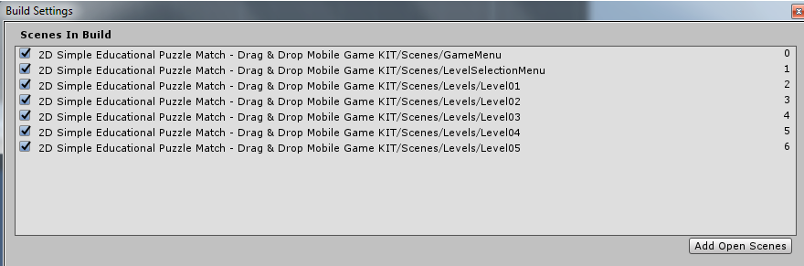

After you add the GameMenu scene then add the LevelSelectionMenu scene and add the other levels from 1 to 5.

They should be like this:

**Game Menu = Scene 0  
Level Selection Menu = Scene 1  
Level 1 = Scene 2  
Level 2 = Scene 3  
Level 3 = Scene 4  
Level 4 = Scene 5  
Level 5 = Scene 6**

Once that is done, test out the package now and it should be working perfectly. That means it should be like this in your BUILD settings. This is important because to load the levels we need the scene numbers, so be sure you have everything right in the BUILD settings already.

**where is the game manager/settings located?**

The main game settings and game manager is the Game Manager (Game Win Settings) Prefab. The game manger will calculate how many shapes you have in order for the game to be win, along with displaying the GUIs, game end sound and much more. You can just click on the game manager prefab, which is the player and see it in the inspector.

This includes everything which can be customized such as the Game Score GUI which is displayed on the screen, the Shapes Left GUI which is also displayed on the screen, the End Game Full Screen GUI which is the full screen background that displays then the game end along with the End Game Score GUI and End Game GUI that displays ‘Game Over’ or anything you wish and followed by the buttons that display when the game ends, such as the Next Game Button and Exit Game Button and lastly, the End Game Sound Prefab which is the sound that plays when the game ends (always needs to be as a prefab) and can be changed from the End Game Sound Prefab’s audio.

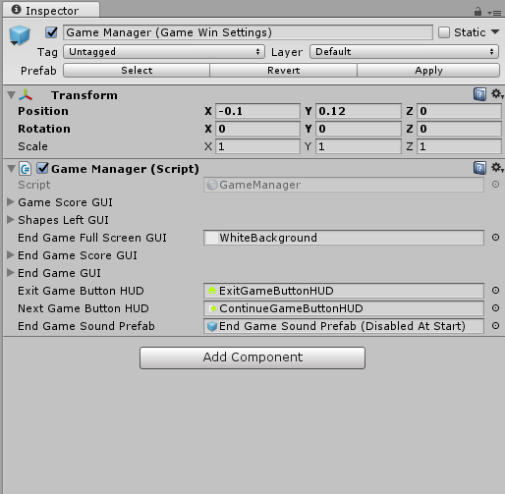

If you like to change the sounds, GUIs, textures speed and such then you need to change that from the player prefab, which is the “Player Ball 1 (Main Player & Game Manager)” in the project. Then on from there you can also change the game end sounds, sounds, background images and much more.

**explaining the DRAG AND WIN SHAPE PREFABS.**

We will explain to you a little on how both the Drag and Win Prefabs works. As you can see, if you go to your Prefabs folder there you have these two type of files:

* Animal Shapes (Drag Prefabs)
* Animal Shapes (Win Prefabs)

These two files are needed to create your game to fit the shapes. If you expand both files you can see there are loads of type of animal shapes which are both the same but one is Drag Zone and the other is Win Zone, so you have for example: Bear Shape (Drag Zone) and Bear Shape (Win Zone).

Now if you put for example the Bear Shape (Drag Zone) in the scene you can see the bear shape, and that is the one that you will be dragging. The other one Bear Shape (Win Zone) is the ‘win zone’ to complete the shape for when you drag the other shape into this one. Go ahead and drag and drop the other one in the scene. Now you can see that the Bear Shape (Win Zone) is black and dark and it always needs to be like this.

Now all you have to do is click on the Drag Zone and there you will see the script Shape 01 and the field ‘Win Zone Shape’ and here you will put the Win Zone of that shape which you have into the scene. Just drag and drop the Bear Shape (Win Zone) into that field and you are set!

Now you have two shapes in the scene which are the drag zone which you will be dragging and the win zone which you will drag the drag zone into in order to complete it. You can add as much as you like but you always need to put the same drag zone and win zone in this scene and place the win zone into the ‘Win Zone Shape’ field of the drag zone. (For Example: if you put the Giraffe Drag Zone then put the Giraffe win zone)

It should now work when drag and drop the shape it should move around and if you get it near the win zone it will automatically attach to it. Now you just need to add the Game Manager and other prefabs which we will see in the next step. For now, you got the idea on how the drag zone and win zone works in this package.

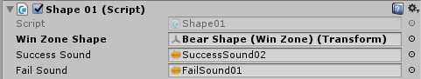

**Quick overview on how to add the shapes ONLY in the scene to work so when you drag the ‘drag zone’ shape into the ‘win zone’ shape it will stick to it – for creating the full-game then go to the next step.**

Drag and drop these prefabs into the scene:

- Bear Shape (Drag Zone)

- Bear Shape (Win Zone)

The win zone are always in BLACK and needs to be in the scene, this is needed for each shape you place in the scene so if you put any other Drag Zone shape then you will always need to put the same Drag Zone shape of it.

Once that is done, you need to set the win zone to your drag zone. Click on your 'Bear Shape (Drag Zone)' and there you will see a ‘Win Zone field’ - Drag and drop the 'Bear Shape (Win Zone)' into it from your scene. YOU WILL ALWAYS NEED TO DO THIS FOR EACH SHAPE YOU HAVE IN YOUR SCENE.

**CREATING YOUR very FIRST GAME, In simple steps.**

This packages comes with all ready to use prefabs, so you can just drag and drop and only have to worry about creating the levels. This KIT will allow you to setup a puzzle animal faces match type game in 2D.

**1. Create a new scene and delete the Main Camera.**

**2. Go on your Prefabs > Settings folder and there you will have all the settings to setup your game.**

**Drag and drop these prefabs into your scene;**

- Background Music - (To play music in your background scene)

- End Game Sound Prefab (Disabled at start) - (This is to play the end game sound when the game ends)

- Game Manager (Game Win Settings) - (This is the prefab to win the game, display GUIs and everything)

- Main Camera - (The main camera for the game with features ready such as fade out etc.)

- Particle System - (Totally optional, this is just a particle effect to make your game look better)

- Tutorial Text - (Totally optional, this is to display a text that will fade out in 5 seconds)

- Level Manager (Unlock Next Level) - (This is only needed to unlock next levels in level selection menu)

**3. Once you put all the main important prefabs in your scene, then you can start to set it up.**

Click on the Game Manager (Game Win Settings) and there you have the main game settings fields, such as Game

Score which you can customize, Shapes Left GUI, End Game Screen and so on. Go on the End Game Sound Prefab

Field in your Game Manager and drag and drop the 'End Game Sound Prefab (Disabled At Start) In your scene to

the End Game Sound Prefab in the Game Manager. This is to play the sound when the game ends which can be changed from the prefab.

**4. You are now ready to place the shapes. These are split into two folders one for the shape to be dragged and the win zone.**

Go in Prefabs folder and there you have 2 important shapes folders. These are the Animal Shapes (Drag Prefabs) which are the ones that can be dragged and the Animal Shapes (Win Prefabs) and these are the ones that needs to be dragged onto.

Go ahead and drag and drop these two prefabs into your scene:

- Bear Shape (Drag Zone)

- Bear Shape (Win Zone)

The win zone are always in BLACK and needs to be in the scene, this is needed for each shape you place in the scene so if you put any other Drag Zone shape then you will always need to put the same Drag Zone shape of it.



Once that is done, you need to set the win zone to your drag zone. Click on your 'Bear Shape (Drag Zone)' and there you will see a Win Zone field. Drag and drop the 'Bear Shape (Win Zone)' into it from your scene. YOU WILL ALWAYS NEED TO DO THIS FOR EACH SHAPE YOU HAVE IN YOUR SCENE. Just like in the screenshot above.

**5. You are basically done, if you done it right you can place more shapes in the scene and the game automatically collects how many shape you have and once you done, the game is won.**

**The quick over-view for setting up your game, easy.**

This is a quick-setup on how to start and which prefabs you need in your scene to create your own drag and drop game. If you followed the steps correctly as described, then you should have a very similar scene to this one below where you can drag and drop the shapes into the win zones and the game is won.

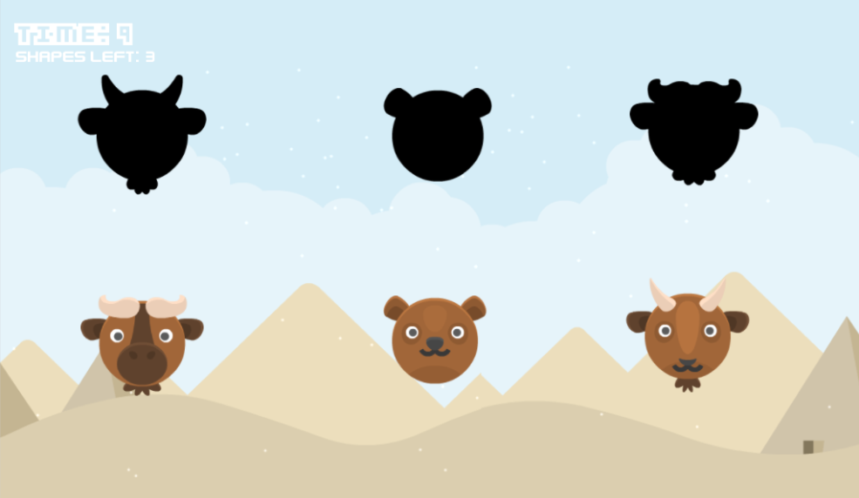

**1. Create a new scene and delete the main camera.**

**2. Place these prefabs into your scene;**

- Background Music  
- End Game Sound Prefab (Disabled at start)   
- Game Manager (Game Win Settings)   
- Main Camera   
- Particle System  
- Tutorial Text  
- Level Manager (Unlock Next Level) - (This is only needed to unlock next levels in the level selection menu)

**3. Click on the Game Manager (Game Win Settings) and put the End Game Sound Prefab (Disabled At Start) in the field of 'End Game Sound Prefab'. You can change the game end sound from this prefab too.**

**4. Place a drag zone and a win zone shape from the PREFABS folder. Be sure to click on the drag zone in your scene and put the win zone in your scene to the drag zone's field where it says 'Win Zone Shape'. This is needed for each shape you have in your scene.**

**5. You are basically done, if you done it right you can place more shapes in the scene and the game automatically collects how many shape you have and once you done, the game is won.**

**over-view of all the prefabs needed for your game**

These are the prefabs that you should have in your scene in order for the game to work, remember to do the essentials in step 7/8 such as putting the End Game Sound Prefab In The Game Manager and placing the Win Zone shape into the Drag Zone’s Field in the inspector if you get some errors (just like in the screenshot below).

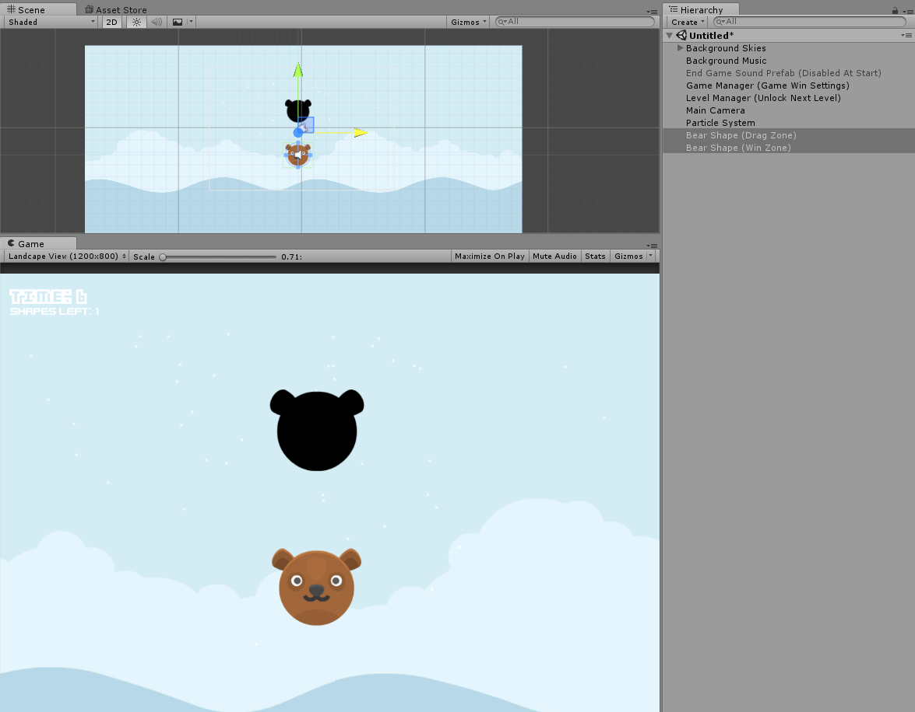

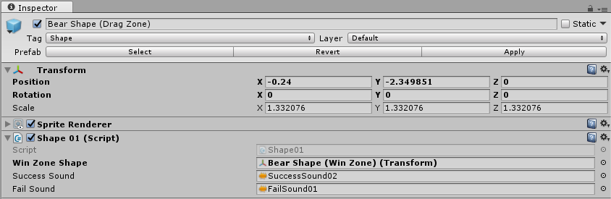

**important reminders to keep in mind**

If you get an error when dragging the Drag Zone shape and won’t fit in the Win Zone shape, be sure that you put all the shapes correctly in the scene and you attached the Win Zone always to the same Drag Zone’s Win Zone Shape Field in the inspector on Shape01 script. You will need to do this for EACH SHAPE YOU HAVE IN YOUR SCENE.



If you get an error when you finish the game it could be because the End Game Sound Prefab was not found. Be sure you place the End Game Sound Prefab (Disabled At Start) in your scene and placed it into the Game Manager’s End Game Sound Prefab field in the GameManager.cs script in the inspector.



You can also change the game ending sound from the End Game Sound Prefab. There are two audio sources onto the prefab and you can just change them to your needs.

**Creating your own shapes from scratch, easy**

This package includes about 20 different shapes which you can use directly by just drag-and-drop into the scene and also includes about 100+ other sprites. You can create your own shapes and set them as part of the puzzle easy and we will show you how.

**Step 1:** Place your sprite that you wish to use into your scene and duplicate it, name one as Drag Zone and the other as Win Zone. Click on the Win Zone sprite and set its color to black.

**Step 2:** Click on your Drag Zone shape and drag and drop the Shape01 script from the Scripts folder. There you have 3 fields which are Win Zone Shape, Success Sound and Fail Sound. In the Win Zone Shape place the Win Zone sprite you created the one with the color set to black and in the success and fail sound put a sound of your choice.

**Step 3:** Add a Box Collider 2D and an Audio Source into your Drag Zone shape. Once you are done, you should have something like this scene below. If you play the scene, it should be working fine and you can drag and drop the Drag Zone with your mouse (or finger on mobile) and if you place it near the Win Zone it will connect.

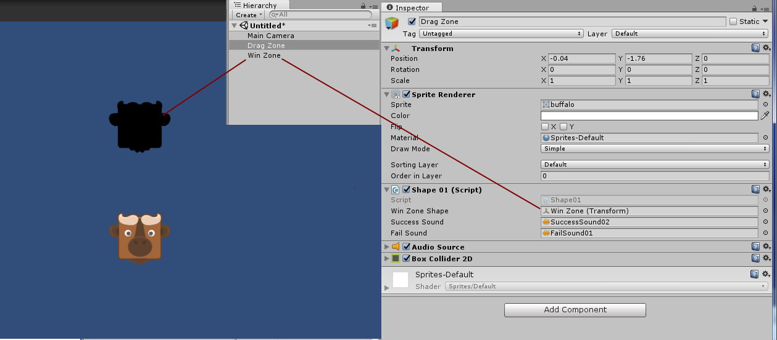

Your game is finished and you just created a new shape and you can now add as many shapes as you like. Add the Game Manager and the other prefabs in your scene and you are ready to go!

The game manager calculates how many shapes you have in the game so it’s very easy and hassle-free. It won’t matter how many shapes you add in the scene, If you add 3 shapes, 5 shapes or just 1 shape in your scene then the game manager will automatically calculates how many shapes you have and once you finish them, the game is won.

**Below we will now show you some information about the neat feature of the level unlock system which unlocks levels as you progress the game.**

**EXPLAINING THE game build settings and levels.**

Before we can start on the level unlock system we need to first go through the BUILD settings to get a clear idea on how it works. Basically you will need to create level scenes and add them to your BUILD settings in order to play. The project contains 5 levels but you can create more and if you do, just add them to your BUILD settings. For this example we will be going with the same scenes we have from the project.

Go to your FILE > BUILD SETTINGS and you should see something like this. You can find the scene numbers in FILE > BUILD SETTINGS AND SCENE IN BUILD. There near your scene you will have the numbers (0, 1, 2, etc.) of each scene.



These are the levels, mostly new project won’t have so you need to create your own levels by saving the scene and just add them by clicking the ‘Add Open Scenes’.

Now in order to make the level unlock system, you will need a level selection menu which we will give you more information about it in the next page. For now, we will just add the Game Menu, Level Selection Menu and all the levels. As you can see on the right of each scene there is a number and this is the scene number.

The first scene should ALWAYS be the MENU which will be scene 0 and the second scene will be the level selection menu scene which will be scene 1. Then the levels should follow up right after that with level 1 to be scene 2 and level 2 to be scene 3 and so on.

That means it should be like this in your BUILD settings:

**Main Menu = Scene 0  
Level Selection Menu = Scene 1  
Level 1 = Scene 2  
Level 2 = Scene 3**

This is important because to load the levels we need the scene numbers, so be sure you have everything right in the BUILD settings already.

You can also not add a main menu if you like and just add a level selection menu, but this will start the game with the level selection menu scene. The scene 0 will always be the start of the game when it gets launched. Now that we have everything in the BUILD SETTINGS we can move on for the levels unlocking features.

**EXPLAINING THE level selection menu part 1**

The project have a scene called ‘Level Selection Menu’ and this is the level selection screen with buttons which you can press on and then you will be taken to that level. Now, we want that the player ALWAYS start at level 1 and all the other levels are locked and move on from there so level 2 will always be locked at first and if the player completes level 1 and advances to level 2 then he can continue back on level 2 so the ‘progress is saved’ when he returns.

Now in this scene you will see that you have the buttons (level 1, level 2 etc.) and these are GUIs sprites with a BOX COLLIDER 3D attached on them which you can click and advance levels, each levels have the different script called Load Scene so each level will be loaded if the player clicks on it. These scripts are the ‘Load Levels Scripts’ which can be found in PREFABS > SCRIPTS > LOAD LEVEL SCRIPTS and they will load a scene of your choice from the build settings. **For example:**

Level 1 Button have the Load Scene 02 attached, so when that button is clicked then scene 2 is loaded.



The scene numbers are from the BUILD SETTINGS we spoke about earlier so all the ‘Load Scene Scripts’ are scripts to load a scene when the button is clicked. That means for Level 2 button the Load Scene 03 script is needed because it will load the scene 3 – which is level 2 in the build settings.

This script is needed for each level button, so if you add another scene which will be Level06 in the BUILD SETTINGS which will be scene 7 then you need to add the LoadScene07 script attached to a Level 6 Button that you will create.

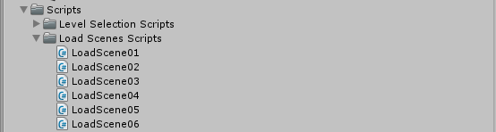

The ‘Load Scene Scripts’ will only load the scenes in the build settings, so for example the LoadScene01 script will load scene 1 in the build settings, the LoadScene02 script will load scene 2 in the build settings and so on. That is why it’s important that you have everything set up in the build settings in order for the level unlock system to work. **Basically the end numbers of ‘LoadScene’ (**LoadScene**01,** LoadScene**02 etc.) is the number which scene it will load from the BUILD SETTINGS.**

**EXPLAINING THE level selection menu part 2**

Now that you have an idea on how to load the levels with the LoadScene scripts from the build settings we can move on to locking the buttons so the player can only advance to level 2 if he completed level 1 so it will ‘save the progress’ and continue where the player left off.

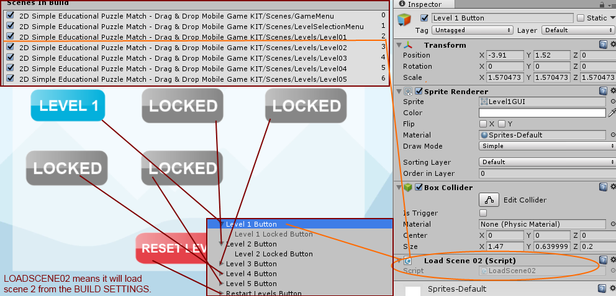

Now you know that each LOADSCENE script is attached to a button to load a scene from the BUILD settings. All buttons need to have a BOX COLLIDER 3D in order to work and NOT a box collider 2D.

Level 1 will always be unlocked so the Level 1 Locked Button is disabled. The other levels will be locked at start, so they will need to have the Locked Button set a child to them and be sure that the Locked Buttons have a BOX COLLIDER 3D too and are always in front of the buttons, the layer of the LOCKED BUTTONS needs to be 1 and for the normal buttons needs to be 0.

Level 1 Button have the Load Scene 02 attached, so when that button is clicked then scene 2 is loaded.



**EXPLAINING THE level selection menu part 3**

Now that you know about the level selection menu you have level 1 unlocked and all the others (level 2 button, level 3 buttons etc.) have a LOCKED BUTTON set as a child for each button with BOX COLLIDER 3D.

Now in the scene, there is a prefab called ‘Level Menu Unlock Manager (Unlock Levels)’ and this is the level manager to unlock the levels when you complete them.

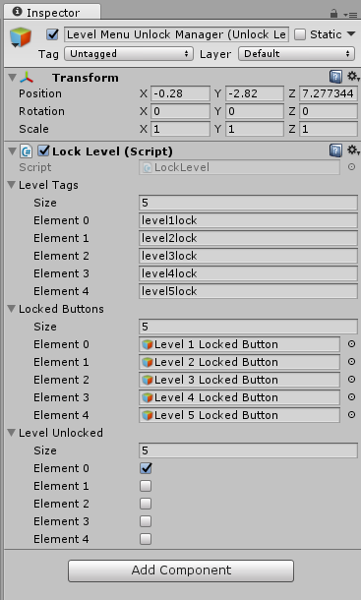

Now you have to put the level tags which will be the same ones you will be using in each scene which is the Level Manager (Unlock Next Level) prefab in the scenes. These needs to be the same as the ones in the scenes. For **Level Tags**, you just put how many buttons/scenes you have and name them level1lock, level2lock etc. This is the tag that will be used on the scene in the Level Manager (Unlock Next Level) prefab when the level is completed. In the **Locked Buttons** you need to put all the LOCKED BUTTONS of the main buttons in the elements. The **Level Unlocked** you just need to put how many level scenes you have and that’s it, always tick the first level since it will be not locked.

**EXPLAINING THE level selection menu part 4**

Now the last step is to have the Level Manager (Unlock Next Level) in each scene that will unlock the next level. So for example, for level 1 you will need to have this prefab called ‘Level Manager (Unlock Next Level) with the same tag that you used to unlock the LEVEL 2 button – which is the SAME TAG from the Level Menu Unlock Manager (Unlock Levels) prefab in the level selection menu.

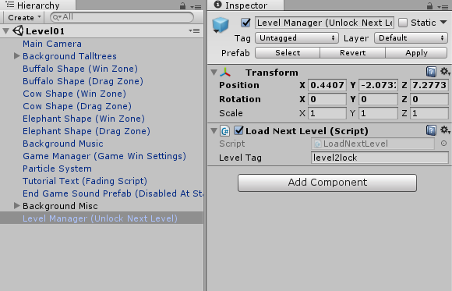

This means that for level 1 you will unlock level 2 – so you will be using the same tag that unlocks level 2 from the same level selection menu. The tag is level2lock.



**creating level selection menu step-by-step**

This is a step-by-step on how to create the level selection menu and add levels.

**Step 1:** First see that you have the scene which are the levels in your BUILD SETTINGS. Go to your FILE > BUILD SETTINGS and you should see something like this. You can find the scene numbers in FILE > BUILD SETTINGS AND SCENE IN BUILD. The scene numbers are near your scene - you will have the numbers (0, 1, 2, etc.) of each scene. **That means that you will have the Game Menu as scene 0, the Level Selection Menu as scene 1 and level 1 will be scene 2 and so on.**



**Step 2:** Go in your Level Selection Menu and you will see the buttons and everything there, see that you have the Level Menu Unlock Manager (Unlock Levels) prefab and you can change how many levels you got from there. All the buttons will have the scripts ‘LoadScene01, 02, 03 etc.’ and these are to load the scene. That means that to load level 1, you will need to add the ‘LoadScene02’ script since level 1 is scene 2. The number at the end of ‘LoadScene’ script is the number which scene will load. You can create your own LoadScript to load a scene. Level 1 Button should have nothing on it, but the others needs to have a LOCKED button. Both of the buttons (locked and not) needs to have a BOX COLLIDER 3D.



**Step 3:** Go to your levels and just be sure you have the ‘Level Manager (Unlock Next Level)’ set the same as the unlock levels in the Level Menu Unlock Manager from the Level Selection Menu scene. You will always needs to have the same tag for the levels. That means for level 1 you need to use level2lock to unlock level 2 and so on. This will disable the locked button and then you can press the main button.

**Step 4:** Be sure that in the level scene you have the **Level Manager (Unlock Next Level)** and that it’s the same tag for the other **Level Menu Unlock Manager (Unlock Levels)** in the Level Selection Menu. That means for level 1, in the tag should be level2lock so it will unlock level 2. For level 2, the tag should be level3lock to unlock level 3 and so on.





**Step 5:** You should be basically done, when you finish a level if they are in the BUILD settings it should unlock the levels if you have the locked button.

**how to add another level unlock button in menu.**

This is a step-by-step on how to add another button in the level selection lock menu and when you have a new scene that you done yourself (basically on how to add another level).

**Step 1:** First create the scene and all and save it. Add it into the BUILD settings by clicking on Add Open Scenes. Name the new scene Level06 (to complete with level 05)

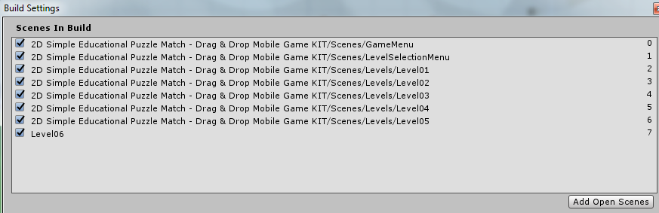

**Step 2:** Click on the new scene, be sure that in your scene you have the ‘Level Manager (Unlock Next Level)’ prefab and in the Level Tag put level7lock – this means it will unlock level 7 when level 6 is completed.

Now you will need to do this for level 5 to unlock level 6 button. Click on the level 5 scene you have and in the prefab be sure that you have the level tag set as level6lock and this is to unlock the next level, level 6.

This means that you will always need to do a level before to unlock it – level 1 unlocks level 2 (level2lock), level 2 unlocks level 3 (level3lock) etc.

Level 1 – level2lock  
Level 2 – level3lock

And so on...

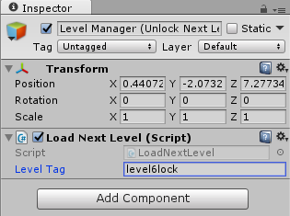

**Step 3:** Click on the Level Selection Menu scene and click on Level 5 Button and duplicate it. Name it level 6 button and name its child lock as Level 6 Locked Button. Click on the **Level Menu Unlock Manager (Unlock Levels)** and in the Level Tags size put 6 and put the last tag for your level which is level6lock, the same tag you put in your level 6 scene. Put the Locked Buttons size to 6 and drag and drop the Level 6 Locked Button in the last field and just put again the size to Level Unlocked to 6 and that’s it.

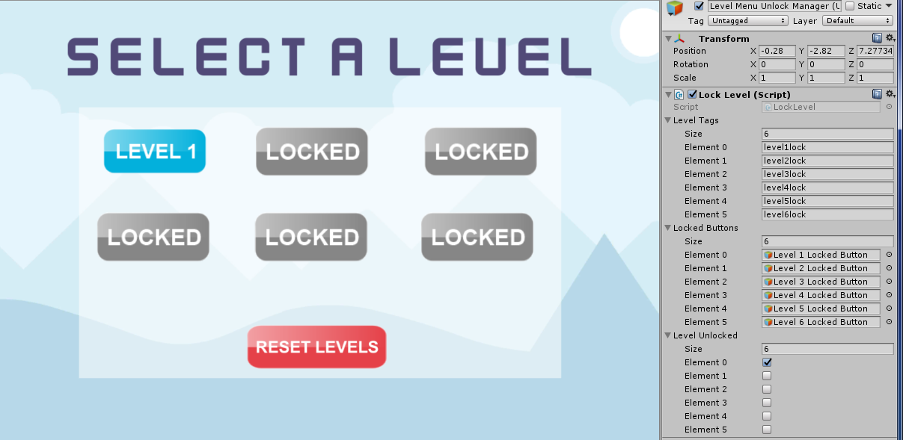

**Step 4:** Click on the button you duplicated which should be Level 6 Button and just be sure that you have both BOX COLLIDER 3D to both the button and the locked button set. Then there you should see the LoadScene script. Create a new LoadScene script (page 20) to load the scene level 6. You can find the number of the scene of level 6 from the BUILD SETTINGS.



As you can see, the level06 scene is scene 7 so we need to load scene 7. Drag and drop the LoadScript07 in the Level 6 Button if you created it. **SEE THE PAGE BELOW ON HOW TO CREATE NEW LOADSCENE SCRIPTS if you need more.**

It should almost be done, save the scene and play the levels. If you play level 5 then once you completed it should advance to level 6. If you go back to the ‘Level Selection Menu’ then level 6 button should be unlocked and you can click on it! You can also restart your save from the start.

**creating another loadSCENE SCRIPT**

You can create as much as you like, these are just scripts to load the scenes from the BUILD SETTINGS below.



Find the Load Scene Scripts folder and see which the last script is. If you have LoadScene06 last then we will be creating LoadScene07. Create a new C# by clicking the right mouse button > create > C# Script and name it LoadScene07.

Open up the script, delete the Void Start and Void Update and add this:

    void OnMouseDown() {  
        SceneManager.LoadScene(+7);  
    }

At the top under Using Unity.Engine add this:

using UnityEngine.SceneManagement;

The (+7) is the number which scene will load, so 7 will load scene 7 and 8 will load scene 8 from the BUILD SETTINGS. The script should basically look like this:

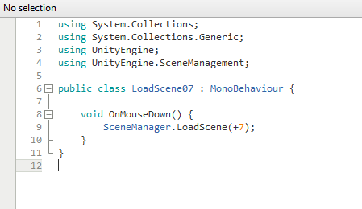

You are basically done, save the script and that’s it! You can add a new button and add the script to it.

Finishing your game and f.a.q

If you finished all the steps then you may have a basic idea of all the features in the KIT. Please note that you can use your own sprites instead. Below we will do the F.A.Q and hopefully answer any questions you may have regards the KIT. If you are in doubt or stuck, be sure to check out the F.A.Q below and be free to use the example scenes provided to learn from them. The example scenes and prefabs are a great way to learn more. Enjoy your game making journey!

**1. Who is this KIT made for?**

This KIT is made for anyone who would like to experiment, learn and create a similar or any other game. This KIT will provide you the scripts you need to create it for both new users and who are willing to learn more.

**2. What is this KIT focused on?**

The main reason this KIT was release was for creating any puzzle match game.

**3. Can I add my own sprites instead of the KIT’s?**

You can add as many sprites and edit as your own objects as much as you want.

**4. How do I change the random background music?**

The background music is a prefab in each scene. You can just click on it and change the background music from there for each scene.

**5. How do I change the game end sound?**

The game end sound can be changed from End Game Sound Prefab (Disabled At Start). There you will have AudioSource that you can change to your needs which will be the sound to play when the game ends.

**6. How do I change the game end GUI?**

The end game GUIs is located in the Game Manager (Game Win Settings) and you can change everything from there, including the score, full screen background, buttons and GUIs.

**7. How can I change the score that displays in the scene and in the end?**

This is located in the Game Manager (Game Win Settings) and you can change everything from there, including the score, full screen background, buttons and GUIs.

**8. How can I change the success sound that plays when the puzzle is matched?**

You can change the sounds from the Drag Zone prefab, so for example if you have this shape in your scene ‘Buffalo Shape (Drag Zone)’ then just click on it and there you will see the Shape01 script. These are the Win Zone Shape (which you have to put the win zone of the same shape here) and the two sounds which will play which are Success Sound that will play when the puzzle is matched and the Fail Sound which will play when you get the wrong puzzle matched. You can have different sounds for each shape prefab too!

**9. How can I put ready-to-use prefabs into the scene?**

You can do that by drag-and-drop any prefabs into the scene and just position it to your needs.

**10. How can place any shape to drag and win?**

You can just drag and drop the prefabs from the PREFABS folder and there are two folders which are ‘Animals Shape (Drag Prefabs)’ and ‘Animal Shapes (Win Prefabs)’ and you need to place the same shape so if you put the Bear Shape (Drag Zone) then you need to put the Bear Shape (Win Zone) and click on the Drag Zone and place the Win Zone in the field required where it says Win Zone Shape in the inspector.

**9. When I try to drag the shape it’s not dragging?**

Be sure that the shape have a Box Collider 2D, Audio Source and the Shape01 script. Also be sure all the field in the Shape01 script are filled.

**10. When I drag the shape into the win zone it’s not working?**

This can be that you did not place the win zone in the correct drag zone. Click on the Drag Zone and place the Win Zone in the field required where it says Win Zone Shape in the inspector.

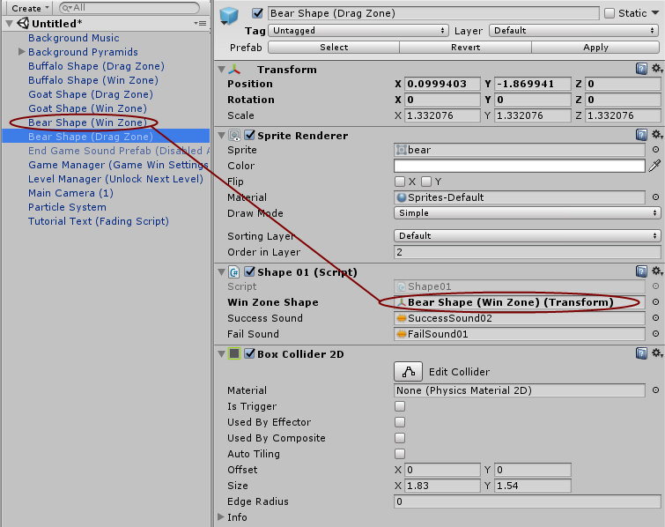

**11. The game is not working when I finish all the shapes?**

Be sure that the drag zone shape is tagged with Shape tag and that you place the same win zone for all the shapes. Also be sure that you have all fields required in the Game Manager Inspector filled.

**12. How can I change the score GUI on the screen or at the win/end game?**

You can change the score GUI from the target prefab in the inspector. There is a score style and score style shadow as GUI which you can customize. These are the score that will be displayed on screen and the other Display Score will be the score that will be displayed when the game will end or won.

**13. How can I change the GUI buttons on the screen? (Home and restart buttons)**

You can find the script on the Game Manager as prefab in the settings folder of the pack. There you will see the Game Manager script and the Exit Game Button HUD and the Next Game Button HUD. You can just change them to your needs.

**14. Can I re-skin this pack?**

Yes and it is easier than ever. All you have to do is just find the prefabs and change the sprite in your Sprite Renderer to your own sprite that you want to use. You can also add your own prefabs and such by applying the tags or scripts in your own sprite.

**15. How do I add the scenes into the BUILD settings?**

Click on FILE > BUILD SETTINGS and just add the scenes from there. Be sure that if you are doing the level-unlock feature then be sure to know all the scene numbers of each level. The image below is an example.

The game menu is at scene 0  
The Level Selection Menu is at scene 1

So to load level 1 then you need to set the LoadScene02 script, because level 1 is at scene 2 and so on.



**16. Buttons in level selection menu are not unlocking when I advance the levels?**

Be sure that you have the prefab called ‘Level Menu Unlock Manager (Unlock Levels)’ in the level selection menu. Also be sure that in each scene to advance the next level you will have the ‘Level Manager (Unlock Next Level)’ prefab. This needs to be the same tag as the one in the Level Menu Unlock Manager (Unlock Levels) to unlock the next level. Example:

If you want to unlock level 2 when level 1 is completed – then in the ‘Level Menu Unlock Manager (Unlock Levels)’ prefab there is the LEVEL TAGS and you will see ‘level2lock’ tag, be sure it’s the same in the ‘Level Menu Unlock Manager (Unlock Levels)’ on level 1. Both tags need to be ‘level2lock’ or anything you want to unlock level 2.





That means if you want to unlock level 2 use the level2lock tag in the scene of level 1 and in the Level Tags in the level selection menu. Be sure you also placed the level 2 locked button in the locked buttons to unlock it.

**17. When I lose and the game ends, it displays the error ‘Level Menu (1) or scene couldn’t be loaded etc.”?**

You need to assign the scenes to the build. Go to the build settings and add the Menu and scenes and then try again. Whenever the game wins it will take you to the next scene when you press the next button.

**18. What are the LoadScene scripts?**

The load scene scripts are scripts to load the scenes from the BUILD settings. If your scenes are not in the build settings then it won’t work and will show an error. Be sure your scenes are in the BUILD SETTINGS after each other. The last number of LoadScene scripts represent which scene it will load (for example LoadScene08 will load scene 8 from build settings)

**19. How do I add the fade-out effect in the Main Camera?**

Go to the scripts folder and drag and drop the FadeScreen.cs script and this will play a nice fade-out when you start the game.

**20. How can I add the color fading effect on the Main Camera background color?**

Go to the scripts folder and drag and drop the ColorFade.cs script and choose two colors of your choice. This will fade the colors in the background to create a nice effect.

**21. How do I reset the level unlock system to restart everything again?**

You have a ‘Restart Levels Button’ which you can click on (Be sure it have the script called ‘ResetLevelButton.cs’ and a Box Collider. You also have a prefab in the Level Selection Folder.

**22. How many level unlock can I add?**

You can add as much levels as you like from the Level Selection Menu, just be sure to set all the Level Tags, Locked Buttons and the tags will be the same with the scene tag.

**23. Camera is too close, how do I change this?**

Go to your Main Camera and from there you can change the Orthographic. Change the size to your camera to 7 for the best results.

**24. How do I add sprites in the scene (as background grass and images and such)**

Go to your SPRITES folder and there is an element folder with some sprites. You can drag and drop them into your scene.

**25. How do I add sprites in the scene (as background grass and images and such)**

Go to your SPRITES folder and there is an element folder with some sprites. You can drag and drop them into your scene.

**26. Why do I hear the End Game Sound play at the start?**

This could be that the End Game Sound Prefab (Disabled At Start) is enabled at start, be sure to disable it so it only play when the game is finished.

**27. How do the tags in Level Selection Menu works?**

You will basically need to have the Level Menu Unlock Manager with the same tags with the ones in your scene. The Level Tag is the prefab in your scene called ‘Level Manager (Unlock Next Level)’ and it needs to have the same tag on which level to unlock. For example we will start with level 1.

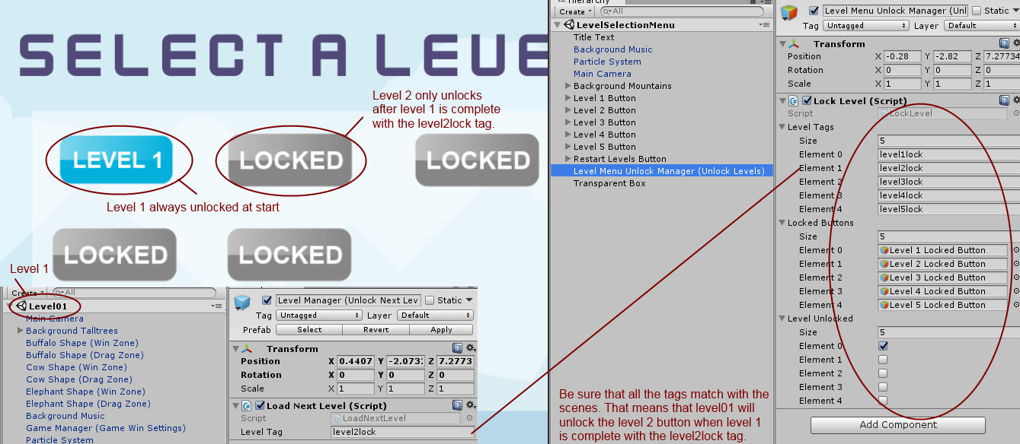

Level 1 is basically scene 2 in the BUILD settings, since scene 0 is menu and scene 1 is level selection.

Now level 1 will always be unlocked so there is no need to place the LOCKED BUTTON on it so it will be disabled, the others will have a LOCKED BUTTON before them with a BOX COLLIDER 3D (ALWAYS A BOX COLLIDER 3D FOR THE BUTTONS) and now when we play Level 1 you will have the ‘Level Manager (Unlock Next Level)’ prefab and the Level Tag on that needs to be for level 2 to be unlocked, which in the Level Selection Menu is level2lock so it needs to be level2lock on level 1 to unlock level 2 button and so on for the others. Level 2 needs to be level3lock to unlock level 3 and so on.

Be sure all field are filled and the locked buttons are in the Locked Buttons fields too, so for level 2 the locked button needs to be set a child to level 2 button and in the Lock Levels inspector. Also if you have 5 levels then put the correct sizes for all of them. Level 1 needs to be there too even if it is unlocked. You can change the tags to your needs too.

**Will this pack be updated and do you have any more planned features?**

This KIT is still young and new and needs to grow and we plan on updating this package. We are working on improving this KIT and if any of you have any suggestions or feedback please don’t hesitate to let me know. We will do our best to update the KIT frequently and even plan on adding more artwork and sprites too apart from the ones that are already in.

If anyone have any inquires or you have any questions or feedbacks please don’t hesitate to contact us on our official website on [www.steelkrill.com](http://www.steelkrill.com).

We hope you create some puzzle games with this, let us know what you did too; we are happy to **see and even share your results/games** with our packages on our social media. Good day!

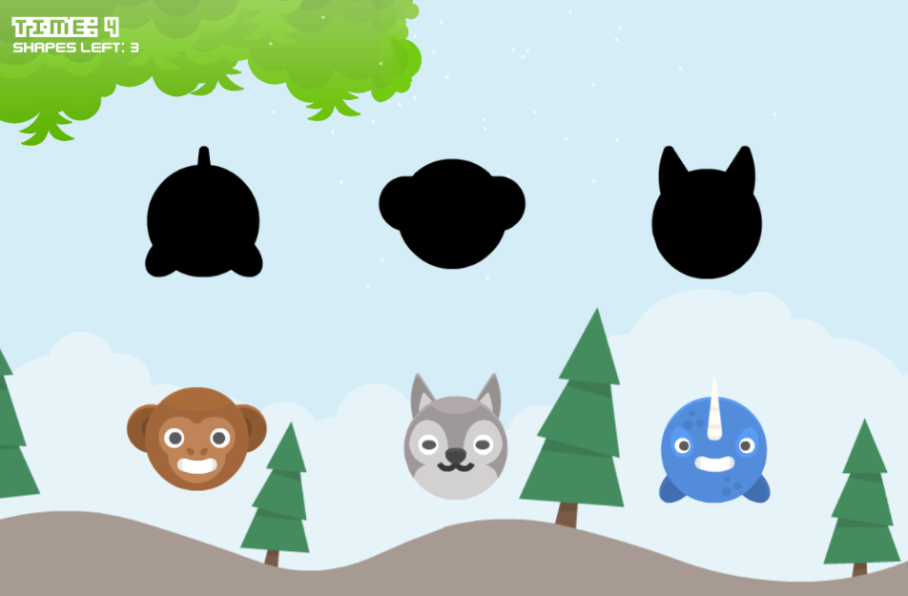

**Happy game making journey!**